**WORK INSTRUCTIONS FOR_** **BF1 & BF2 FLARE STACK**

**Criteria: Complete flaring of BF gas through flare stack.**

# OVERALL RESPONSIBILITY: Furnace in Charge or Shift in Charge in communication with control room in-charge.

**Identified Hazards:**

1. BF Gas poisoning
2. Fall of person causing injury
3. Contact with hot surface causing burns
4. Human Behavior -Nonuse of PPE
5. Human Behavior -Improper house keeping
6. Inadequate local lighting
7. Breaking of flare stack water seal without the knowledge that people were working on top.
8. Human Behavior -Not following work permit procedure.
9. Declaring shutdown without water sealing all the valve of the line
10. Flare stacks flame failure leading to gas presence in plant area.
11. LPG leakage
12. Slipping from monkey ladder while climbing

**Significant Aspect**:

1. Usage of LPG.
2. Release of BF gas without flaring
3. Flue gas generation
4. Use of electrical energy

**Introduction**:

Electric ignition Burner is used on Flare stack for burning the Excess BFG gas which is generated in blast furnace. Burner consists ofLPG line connection. Each flarestack has one burner and GEL has four burners. Full LPG Cylinders stock to be maintained at base of flare stack. Maximum allowed 7 numbers at each flare stack. Minimum one to be connected with required pressure min 1.5Kg/cm2.

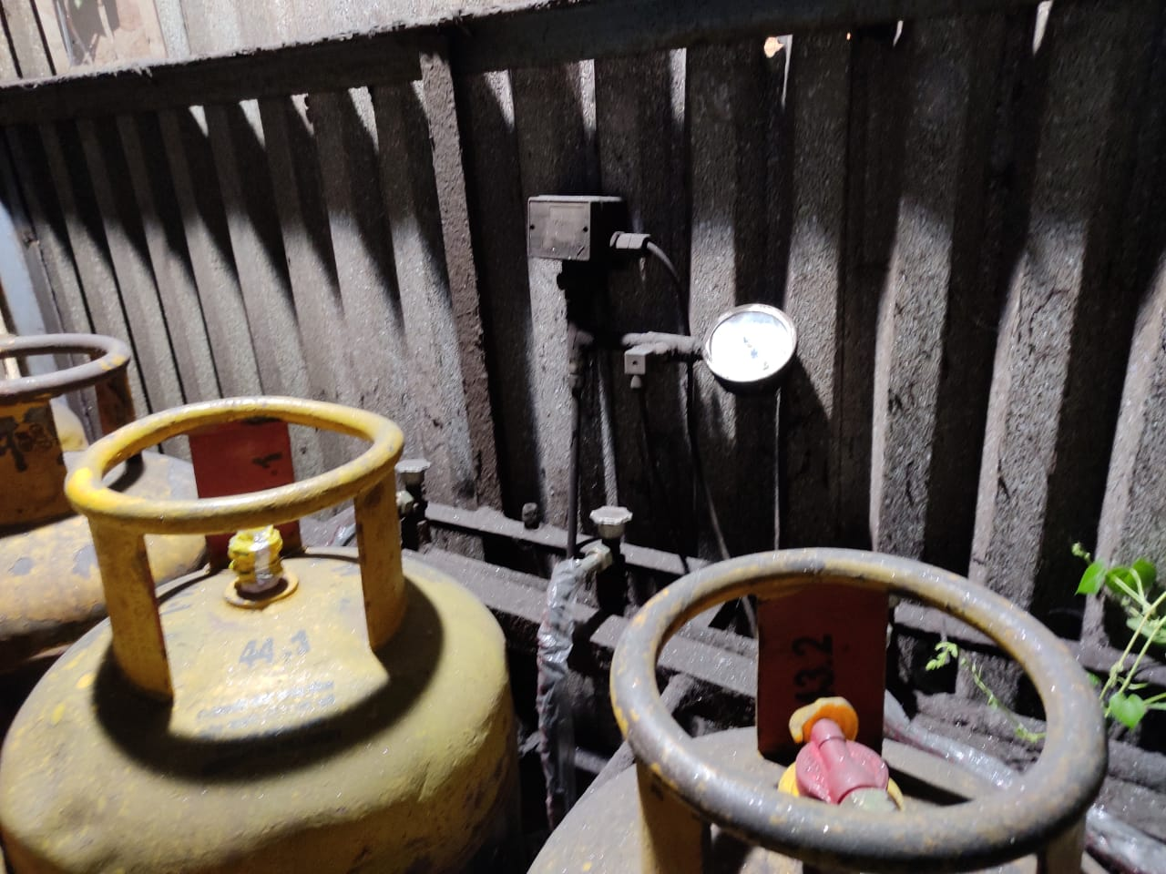

Please refer to SP11 for working of the flare stack set points.

**Procedure for firing burner**:

1. . In BF1 ignition ON button is provided at site panel at the base of flare stack and in BF2 ON button in GAS CLEAN page of PLC in Control room.

~~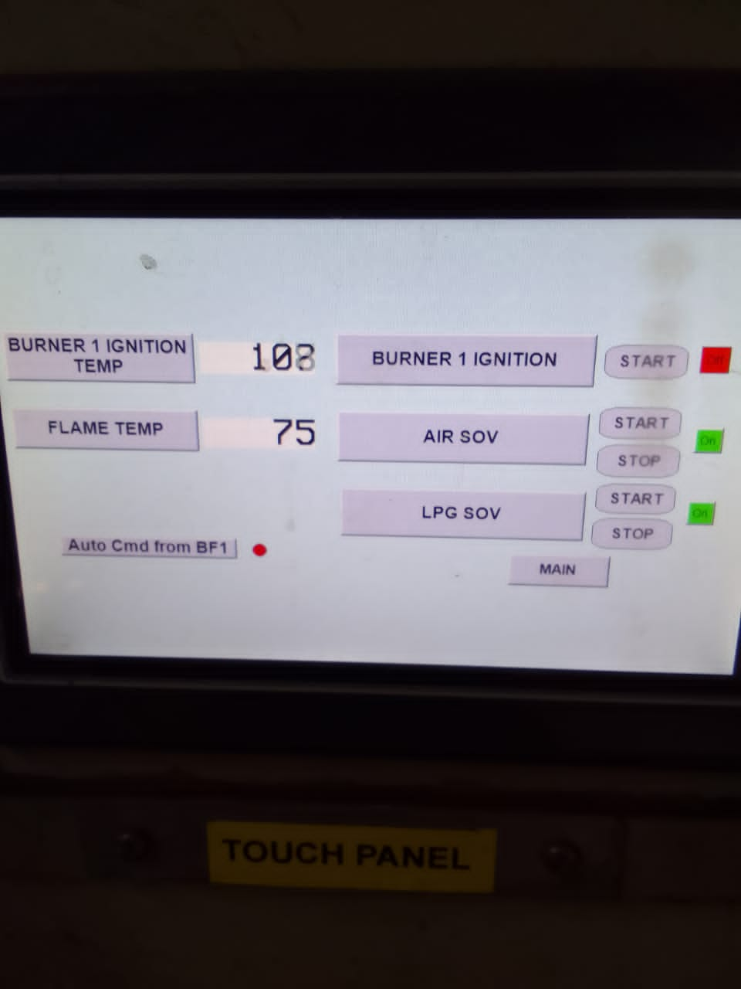~~

~~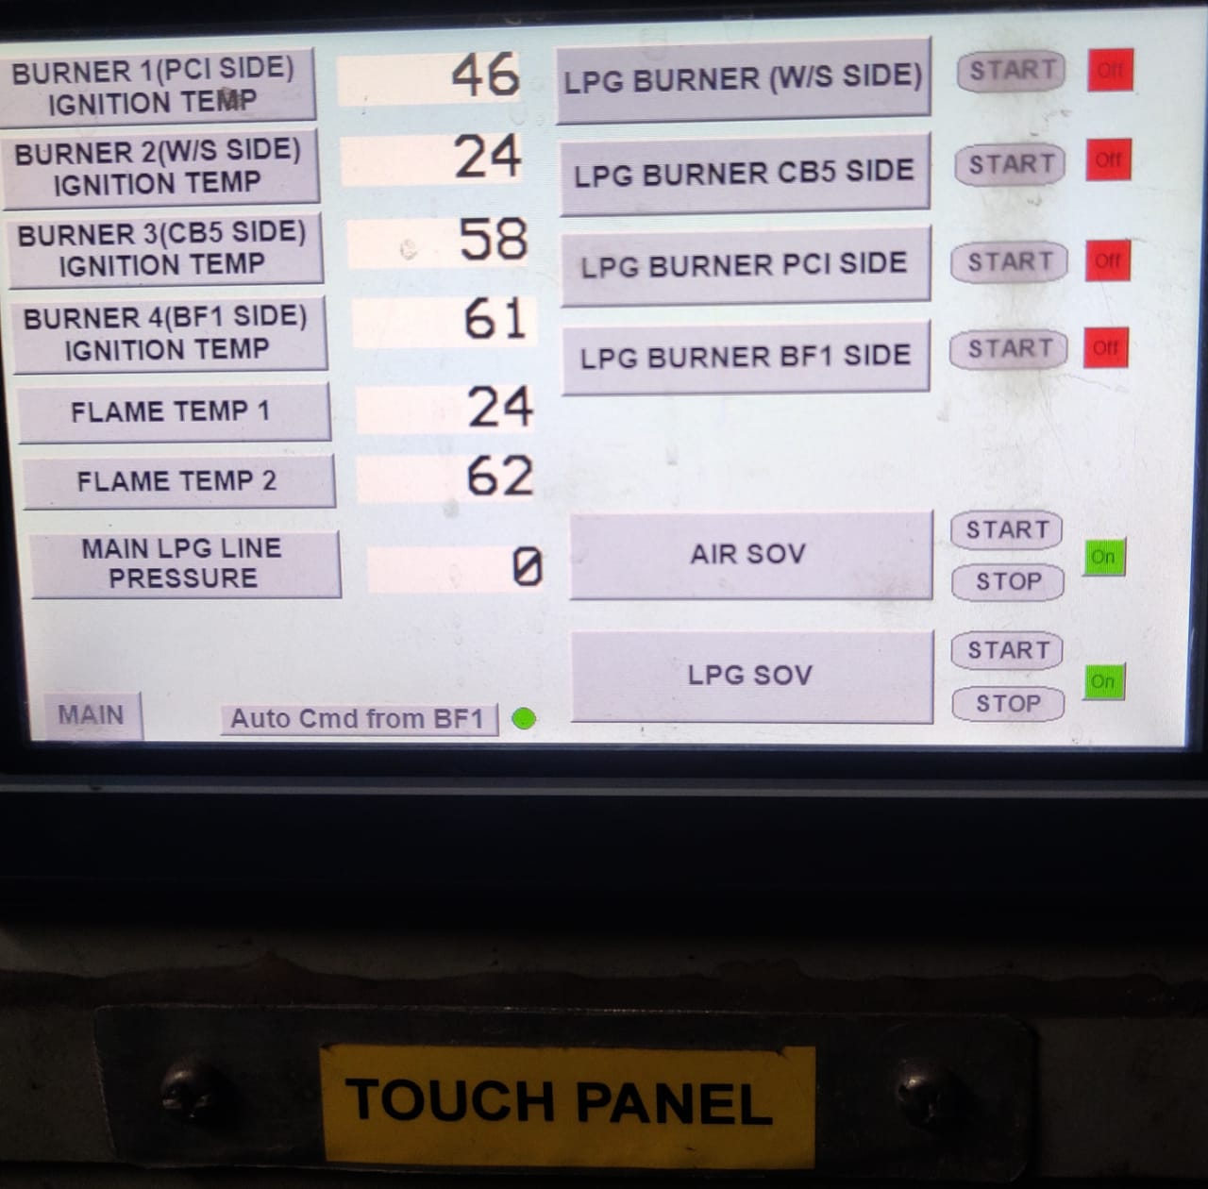~~

1. . Ensure LPG pressure is more than 1.5Kg/cm2 . System operates in two mode (Auto /Manual), in Auto (Green indication) once flare stack is 25% open. Open command goes to LPG SOV ON and Burner ON which gets cutoff in 10sec.

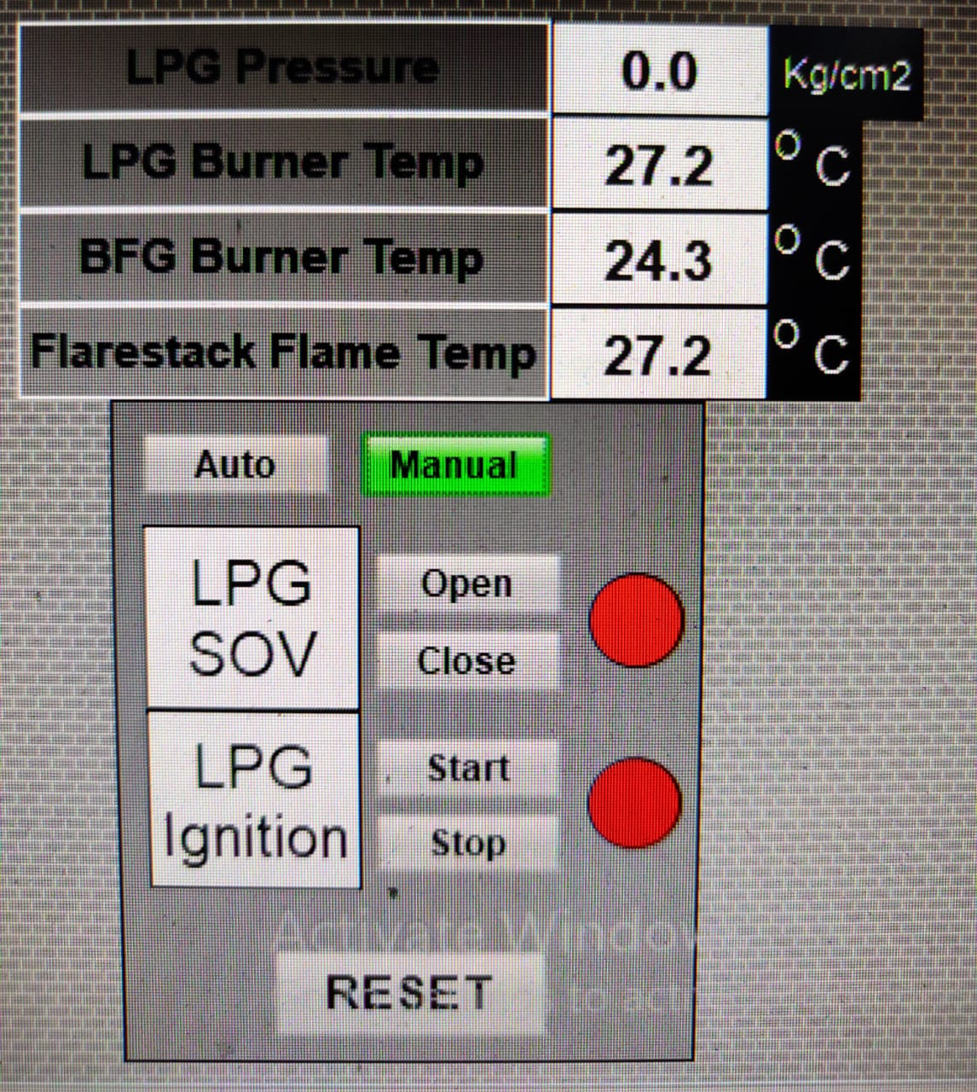

.not in use

1. . For manual firing initially give Ignition command ON. Open flare stack by 25%, when Burner temperature crosses 250⁰C BFG will start flaring.
2. . LPG Cylinder pressure low alarm is given at 0.5 Kg/cm2 in control room. Cylinder to be changed by Furnace in charge or shift in charge.
3. Burner inside temperature is displayed on electrical panel and flare stack top burnt out gas temperature is displayed on temperature indicators on ignition burner control panel. To ensure proper flaring of exhaust gas burner temperature has to around 780-820°C.
4. First Shift SS to update control room in Charge about LPG Cylinder status and inform Store/Inventory in charge to arrange stock if required,

|  |  |  |
| --- | --- | --- |
| **Prepared By:**  Head – Production PID I | **Reviewed & Issued By:**  Management Representative | **Approved By:**  Head – Pig Iron Division |
| **Signature:** | **Signature:** | **Signature:** |
| **Date: 10.07.2023** | **Date: 10.07.2023** | **Date: 10.07.2023** |

|  |  |  |  |
| --- | --- | --- | --- |
| **Amendment Record** | | | |
| **Revision date** | **Manual Section ref. and para** | **Brief details of revision** | **New Revision No.** |
| **15.07.2022** | **Work instructions for BF1 & BF2** | **Procedure for firing of Burner** | **02** |